

Innoventory Mobile

Getting Started

Welcome to the Innoventory Mobile User Manual. In this Manual, we will discuss the functionalities of Innoventory Mobile while showing how to purchase an item step by step. First, run Innoventory Mobile.exe by double clicking its icon.

The Login Screen

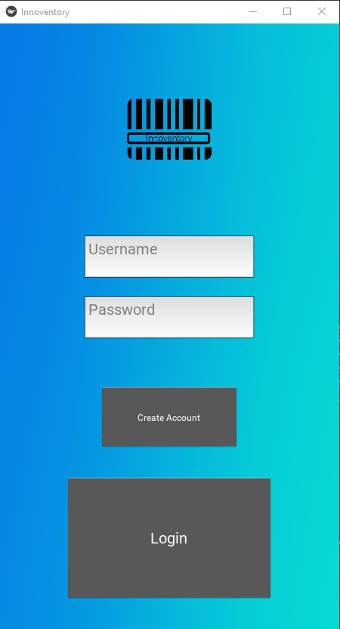

The first page you’ll see upon running Innoventory Mobile is the Login page. From this page you can log in by typing your username and password in the white text boxes labelled “Username” and “Password,” respectively, and then clicking the gray “Login” button. If you’re a new user, you can create an account by clicking the gray “Create Account” button, which will take you to the account creation screen.

The Account Creation Screen

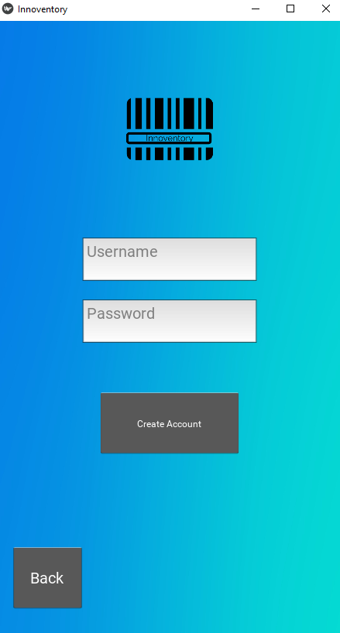

The account creation screen lets you create an Innoventory account that you can use to login. To create an account, type a username of your choice, and a password of your choice into the white text boxes labelled “Username” and “Password,” respectively. Then click the gray “Create Account” button. This will take you to the home screen.

The Home Screen

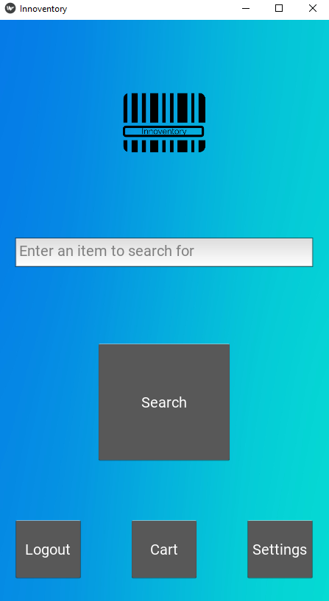

Welcome to the home screen, this is the main hub of Innoventory mobile. From here you can search for an item, log out of Innoventory, view your shopping cart, or go to the settings page.

* To search, type one or more words into the text box labelled “Enter an item to search for.” Then hit the gray “Search” button. This will take you to the results page.
* To log out, click the gray “Logout” button. This will take you back to the login creen.
* To view your shopping cart, click the gray “Cart” button.
* To go to the settings page, click the gray “Settings” button.

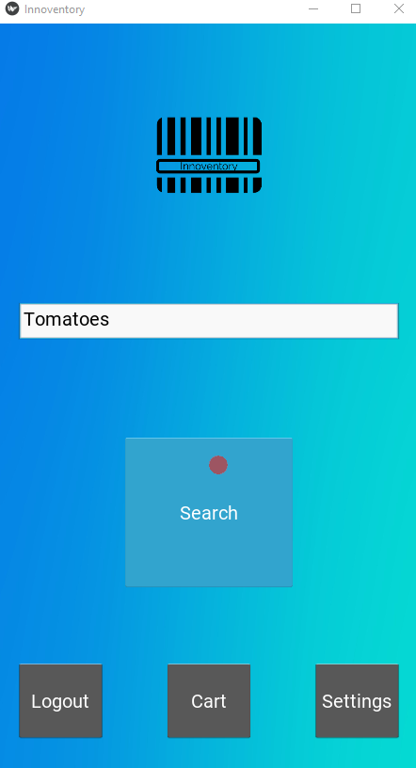

We’ll come back to the settings page later. Right now, we’ll search for “Tomatoes” and click “Search”.

The Results Page

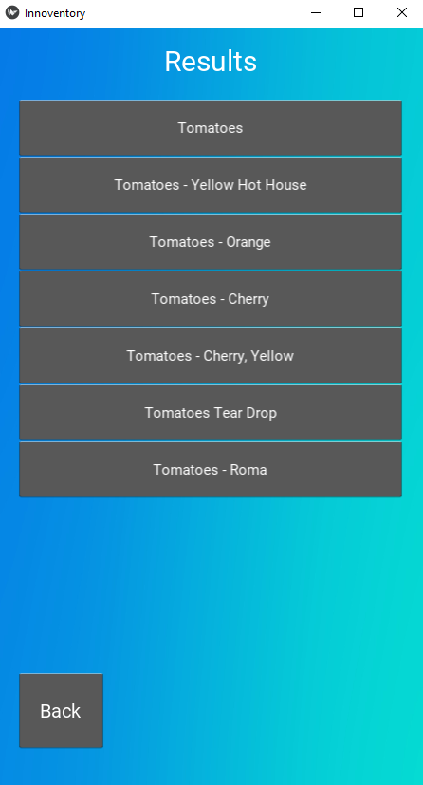

The results page lists all the items relevant to your search. Above, we can see the results for our search. If we click on the gray “Back” button, we’re taken back to the home screen.

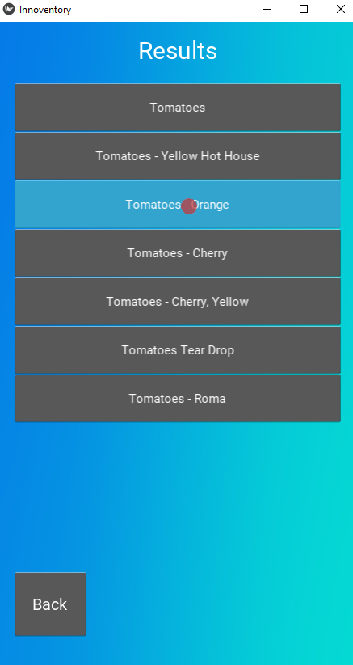

If we click on one of the item boxes, it will take us to the product info page for that item. We will click on “Tomatoes – Orange.”

The Product Info Screen

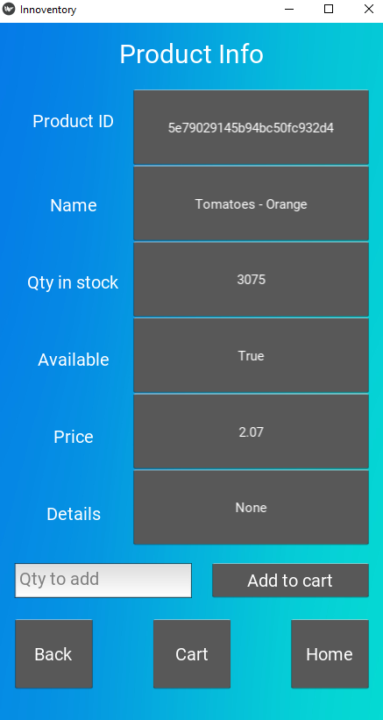

The product info page displays information about the item you’ve selected from the results list. “Qty in stock” shows how many of the item there are to buy. “Available” shows whether or not the item is available for purchase. It is possible for an item to be in stock but not available to purchase. “Price” shows how much a single item will cost. Details includes extra information for some products, such as the year it was manufactured.

* The “Back” button will take you back to the results page
* The “Cart” button will take you to your shopping cart
* The “Home” button will take you to the home screen

To add an item to your cart, type the number you would like to add in the text box labelled “Qty to add,” then click the gray “Add to cart” button.

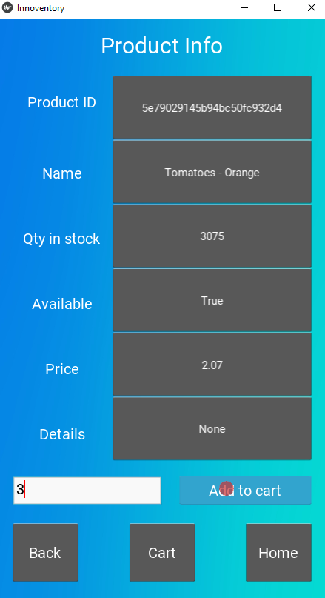

We will add 3 tomatoes to our cart by typing 3 in the “Qty to add” text box, and then clicking “Add to cart.”

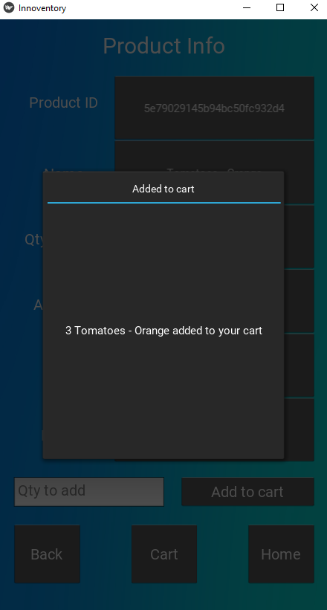

We are shown a confirmation message that the items have been added to our cart.

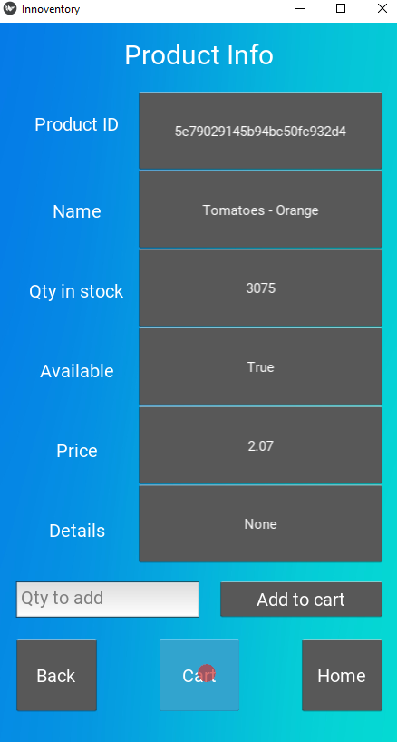

Now we will click outside the popup to close it, and click the “Cart” button to go to our shopping cart.

The Shopping Cart

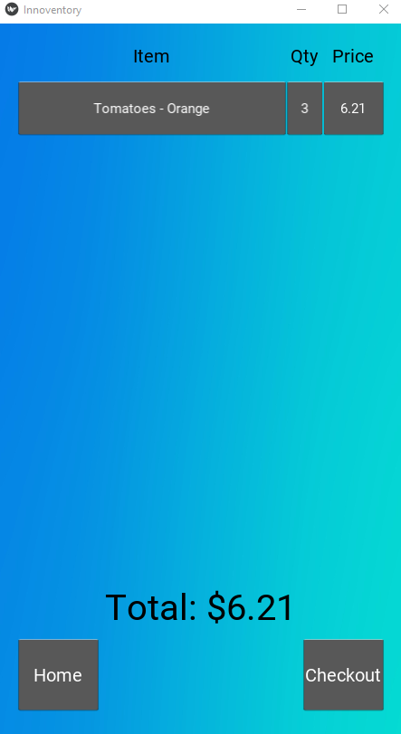

The shopping cart page shows you what items are in your cart, how many are in there, and the total price for each item in your cart. At the bottom, it shows your grand total for all items. The “Home” button will take you to the homepage.

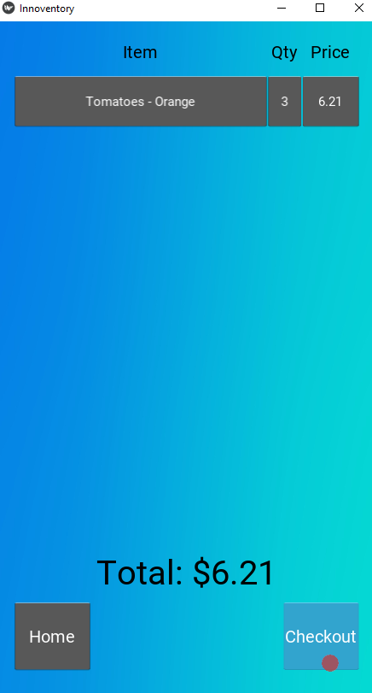

The “Checkout” button will open a popup window that prompts you to confirm the purchase. We will click the “Checkout” button.

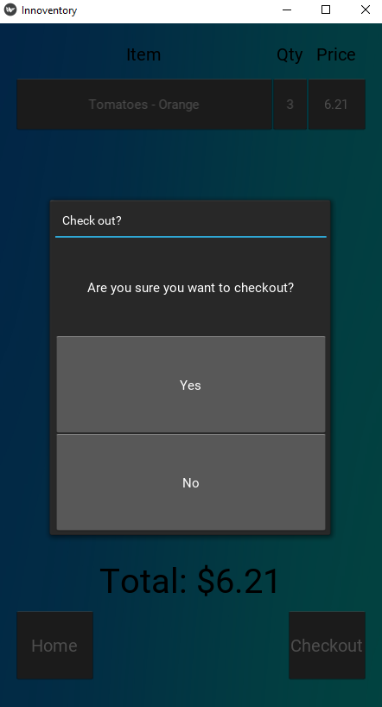

In the confirmation popup, clicking “Yes” will confirm the purchase and return you to the home page. Clicking “No” will cancel the purchase and return you to the shopping cart. We will click “Yes” and return to the home page.

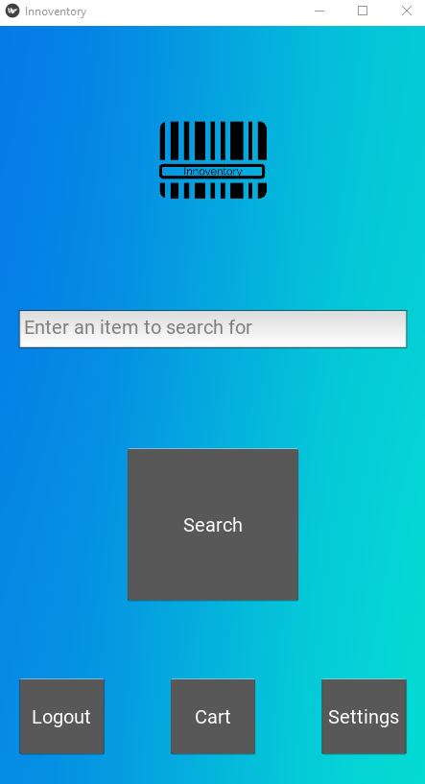

Congratulations, you’ve made your first purchase on Innoventory Mobile! Now we will discuss the settings page

The Settings Page

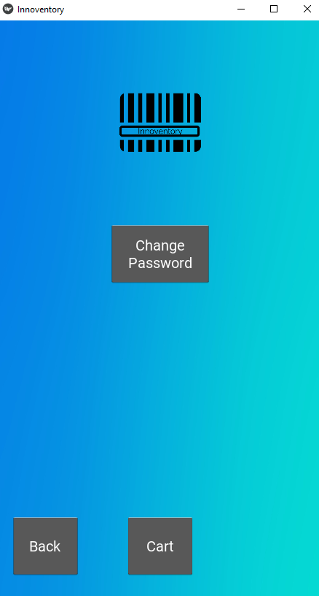

The settings page allows you to change your password. If you click the “Back” button, you will be returned to the home page. If you click the “Cart” Button, you’ll be shown your shopping cart. Let’s click the “Change Password” Button, which will take us to the “Change Password” screen.

The Change Password Screen

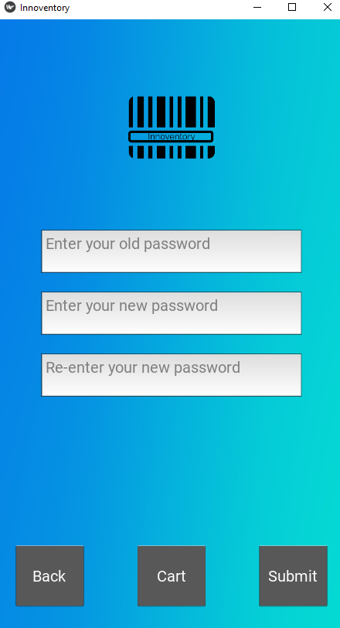

The change password screen allows you to change your password. To do this, type in your old password in the text box labelled “Enter your old password.” Then type your new desired password in the text box labelled “Enter your new password.” Next, re-enter your new password in the text box labelled “Re-enter your new password.”

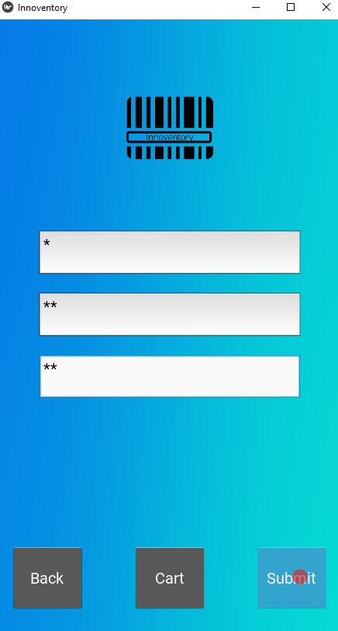

Finally, click the “Submit” button to change your password.

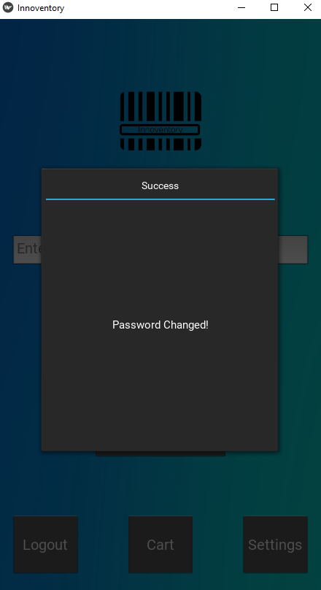

A popup will appear confirming that your password has been changed.

* The “Back” button will take you back to the homepage
* The “Cart” button will show you your shopping cart